Bellabeat Case Study
Data Analysis Report

المحتويات
Business Task 3
Data Sources 3
Data Cleaning & Processing 4
Analysis summary 7
Visualizations & key findings 8
Marketing recommendations (actionable & prioritized) 9

Business Task
The business task is to analyze smart device usage data in order to uncover user behavior trends and preferences. Bellabeat wants to understand how consumers use smart wellness devices, what features are most engaging to them, and how these trends can be applied to improve the marketing strategy for one of Bellabeat’s own products. The goal is to provide actionable insights that help the company grow its user base and increase product engagement.

Data Sources
The dataset used for this analysis was sourced from Kaggle: “FitBit Fitness Tracker Data” (Public Domain – CC0). The data was collected from 30 Fitbit users who consented to share their anonymized fitness tracker data, including minute-level and daily summaries of activity, sleep, heart rate, and calorie tracking.
The dataset is divided into multiple CSV files, each representing a different aspect of the users' wellness behavior. These include:
- dailyActivity_merged.csv: daily activity summary
- sleepDay_merged.csv: sleep patterns
- dailyIntensities_merged.csv: activity intensity levels
- heartrate_seconds_merged.csv: second-by-second heart rate data
- and several more files covering steps, calories, and sleep in various time resolutions
The data was opened and explored using Microsoft Excel for initial inspection and sheet organization. For deeper analysis, data will be imported into R to clean, transform, and visualize insights. Some files needed formatting adjustments due to delimiter issues (e.g., using Text-to-Columns in Excel).
The dataset appears consistent and well-structured overall, though some limitations include a small sample size (30 users) and lack of demographic diversity.

Data Cleaning & Processing

Introduction: Data Preparation Methodology
To ensure the accuracy and integrity of the analyses to be presented, I began with a critical data preparation phase, transforming 11 fragmented worksheets into a single, unified, and structured data source. The starting point was to merge the hourly-level data to establish the relationship between calories, intensity, and steps for each hour.
This step was executed using the Power Query tool in Excel, where I linked the three primary tables (hourlyCalories, hourlyIntensities, and hourlySteps) based on two unique keys: Id and ActivityHour. This approach allowed for the consolidation of all metrics into one coherent table, providing a robust foundation for subsequent analysis.
A significant challenge was encountered in standardizing the date column, which contained non-standard formats. To overcome this obstacle, I applied a precise methodology:
- First, I cleaned the column of any extraneous spaces using the Find and Replace feature.
- Next, I utilized the Text to Columns feature to separate the date and time and isolate the date components (day, month, and year). I then manually standardized the date format to ensure consistency across all rows.
- Finally, after confirming the consistent format, I converted the column's data type to "Date" to ensure its suitability for proper time-series analysis.
Following these steps, I also verified the data's integrity, ensuring the absence of errors, removed empty rows, and converted each column to its appropriate data type (e.g., converting the Id column to text, and numeric columns to numbers).
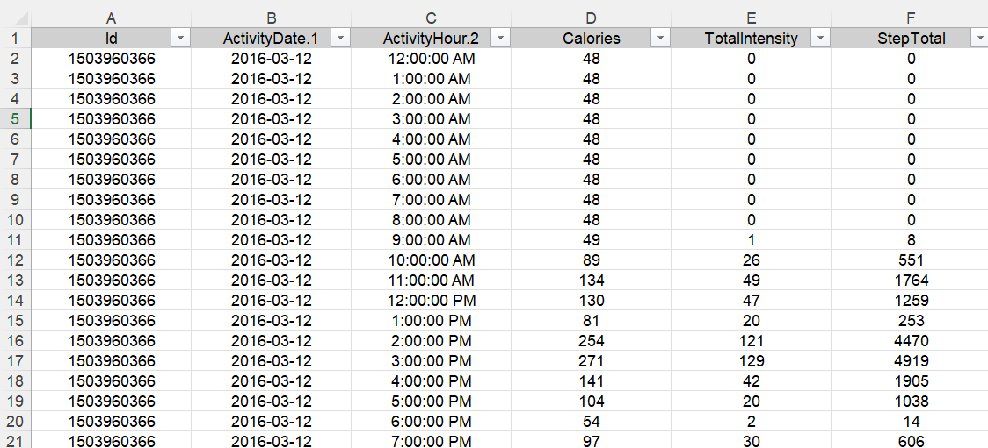

Phase Two: Daily Activity Data Preparation
Summary of Process: As a continuation of the hourly data setup, we moved on to preparing the daily activity worksheet. This phase was aimed at ensuring the daily data is analysis-ready by applying a rigorous methodology to guarantee its integrity and accuracy.
Key Steps:
- Data Cleaning: Any empty or missing rows in the Id column were systematically removed. This ensures the dataset is free of any gaps that could affect subsequent analyses.
- Defining Data Types: To make the data suitable for analysis, the data type of each column was changed to match its content. For example, the Id column was confirmed to be "text," and the ActivityDate column was set to "date" to enable time-series analysis. The data types for other numeric columns, such as TotalSteps, Calories, and TotalDistance, were also standardized.
- Standardizing Formatting: Although the data type changes were successfully applied in Power Query, an additional step was performed to format the cells directly in the resulting Excel worksheet. This ensures the data appears in a clear and consistent visual format (e.g., standardizing decimal places and date formats), enhancing readability and presentation in the final reports.
Outcome: With these steps completed, the daily activity worksheet is now fully prepared for immediate analysis, providing a solid foundation for exploring daily activity patterns and linking them to other datasets.

Phase Three: Minute-Level Data Preparation
Summary of Process: As a continuation of the data preparation phase, we have successfully merged and cleaned all detailed minute-level data. This step was crucial as it provides the highest level of detail, enabling highly granular analyses on the relationship between calories, intensity, steps, and Metabolic Equivalents (METs) for every minute.
Key Steps:
- Creating Connections: First, we created separate connections for each minute-level worksheet (minuteCaloriesNarrow, minuteIntensitiesNarrow, minuteStepsNarrow, minuteMETsNarrow) within the Power Query tool. This procedure allows access to the data as "queries" that can be merged.
- Advanced Merging: Using the Merge feature, the four queries were integrated into a single, cohesive table. They were linked using the unique keys Id and ActivityMinute to ensure the data is precisely matched on a minute-by-minute basis.
- Final Expansion: After the merging process, the new columns that resulted from each merge were expanded, allowing the intensity (Intensity), steps (Steps), and METs data to appear directly next to the calorie data in one final table.
- Data Cleaning: Basic cleaning steps were applied to the merged table. This included removing any empty rows and changing the data types of each column (e.g., converting the Id column to text and the ActivityMinute column to a date/time format), which ensures data accuracy for analysis.
Outcome: You now have a rich and detailed minute-level data source, fully prepared for deep analysis, which allows you to explore minute-by-minute activity patterns and their relationship to effort, calories, and METs. Phase Four: Final Data Preparation
Summary of Process: As a continuation of the previous data preparation phases, the final, crucial step was to clean and prepare the remaining specialized worksheets. This phase focused on ensuring that each unique dataset, including heart rate, sleep, weight, and Metabolic Equivalents (METs), was properly formatted for analysis, completing the entire data preparation process.
Key Steps:
- Heart Rate Data (heartrate_seconds_merged):
  - The Id column was converted to a "text" data type for consistency.
  - The Time column was converted to a "date/time" type to enable precise time-series analysis.
  - The Value column (representing heartbeats per minute) was set to "whole number" to ensure accuracy in calculations.
- Sleep Data (minuteSleep_merged):
  - The Id column was converted to "text."
  - The date column was converted to "date/time."
  - Data types for other columns, such as value and logId, were standardized to a number format.
- Weight Data (weightLogInfo_merged):
  - The Id column was converted to "text."
  - The Date column was converted to "date/time."
  - Numeric columns like WeightKg and BMI were converted to a "decimal number" type.
- METs Data (minuteMETsNarrow_merged):
  - This dataset was successfully merged into the existing minute-level table.
  - The Id and ActivityMinute columns were used as keys for merging.
  - The METs column was then added to the combined table and converted to a numeric data type, enriching the minute-level analysis.
In each of these worksheets, additional cleaning procedures were applied to remove any empty or incomplete rows, ensuring that all data used in the final analysis is reliable and complete.
Outcome: With these steps completed, all of your worksheets are now fully prepared, providing a solid and comprehensive foundation for analyzing every aspect of the collected physical activity patterns.

Analysis summary
The analysis combined daily, hourly and minute-level Fitbit-style data to answer how users interact with consumer wellness devices and what signals best predict meaningful activity. After an initial exploratory phase, we filtered probable non-wear days (threshold: total_steps >= 1000) to improve signal quality and derived several per-user and per-day metrics (mean daily steps, calories, very active minutes, day-of-week, and hour-of-day). Key analytical steps included correlation analysis, per-user aggregation, k-means segmentation (k=3), hourly activity analysis, weekday/weekend comparisons (paired and aggregate tests), and a focused joint analysis of activity with sleep using the minute-level sleep sheet.
Main quantitative findings:
- Correlation analyses: Steps and calories were moderately correlated (Pearson r ≈ 0.50 after filtering). Steps and very_active_minutes showed a strong positive relationship (Pearson r ≈ 0.69), indicating that active minutes are a better proxy for exertion than raw step counts.
- Per-user summaries and top users: We identified the three most active users and observed high within-user variance (examples: mean steps for top users ≈ 17,417; 14,844; 12,640). This variability motivated per-user aggregation and segmentation rather than relying on population averages alone.
- Segmentation (k = 3): Clustering on per-user means produced three actionable segments: Low (~5,300 mean steps/day; n=14), Medium (~9,800 mean steps/day; n=12), and High (~12,600 mean steps/day; n=4). Each segment demonstrates different engagement patterns and therefore different marketing levers.
- Weekday vs weekend: Both aggregate tests and paired per-user comparisons found no statistically significant difference in mean daily steps between weekdays and weekends (paired t-test on per-user means p ≈ 0.92; Welch aggregate p ≈ 0.88). A mixed-effects model controlling for user-level random intercepts likewise found no practical weekend effect (ICC from activity model ≈ 0.50, indicating substantial between-user variance).
- Hourly pattern: Hour-of-day aggregation revealed two clear activity peaks: around 12:00 (noon) and 18:00–19:00 — useful windows for timing notifications and promotional messaging.
- Sleep vs activity: We heuristically aggregated minute-level sleep (counting minutes where value == 1 assumed asleep). Only n = 39 matched day-user records were available for sleep/activity linkage. Correlation between daily steps and minutes asleep was weak and non-significant (r ≈ -0.175, p ≈ 0.29). A mixed-effects sleep model produced non-significant fixed effects and a singular-fit warning — results are underpowered and should be interpreted cautiously.
Limitations to bear in mind: small sample size (30 users originally, smaller matched samples for some joins), lack of user demographic metadata, heuristic sleep aggregation from minute-level flags (the value field appeared to include multiple sleep states), and some model warnings (singular fits) indicating limited power for mixed-effects inference.

Visualizations & key findings
Below are the visuals produced and the concrete insights they communicate. All file names refer to saved outputs in the project (use these images in slides or the portfolio).
Key visualizations :
- Hourly activity profile:
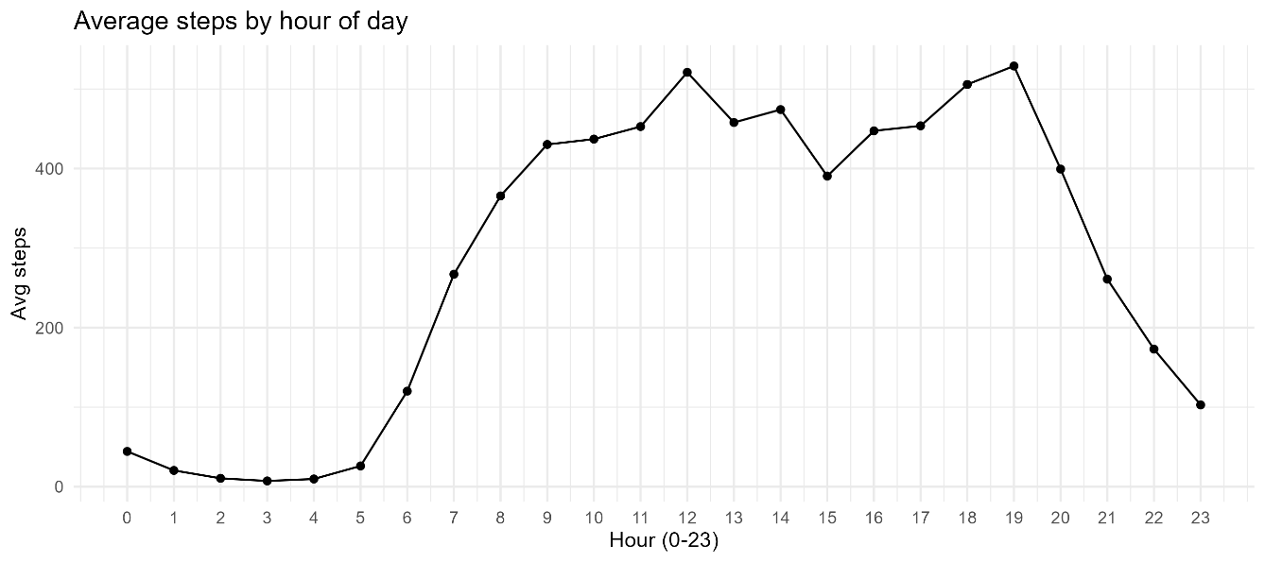
- Insight: two peaks at 12:00 and 18:00–19:00 (best windows to surface nudges).

- Scatter + linear fit: Steps vs VeryActiveMinutes
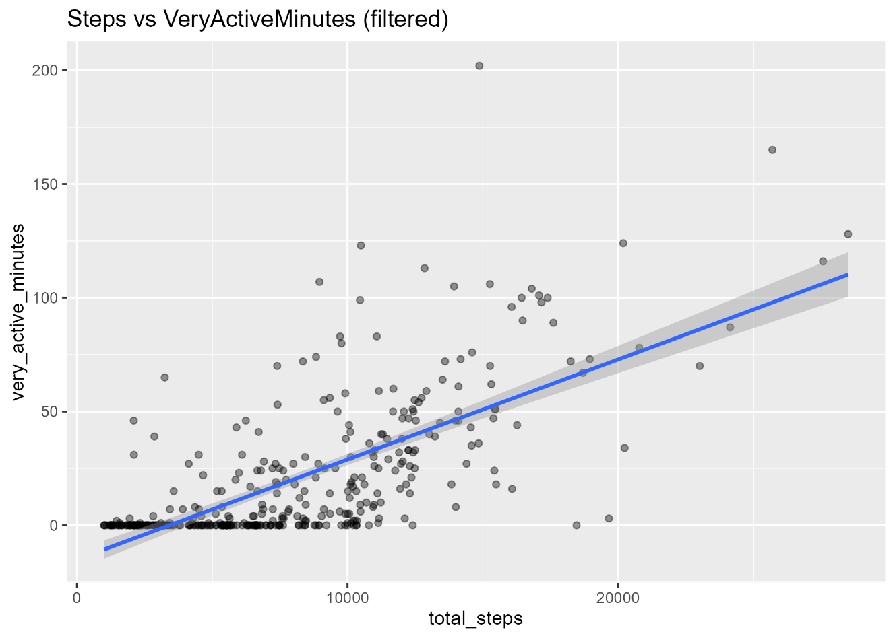
- Insight: strong positive relation (r ≈ 0.69); active minutes are a high-value engagement metric.

- Steps vs Calories
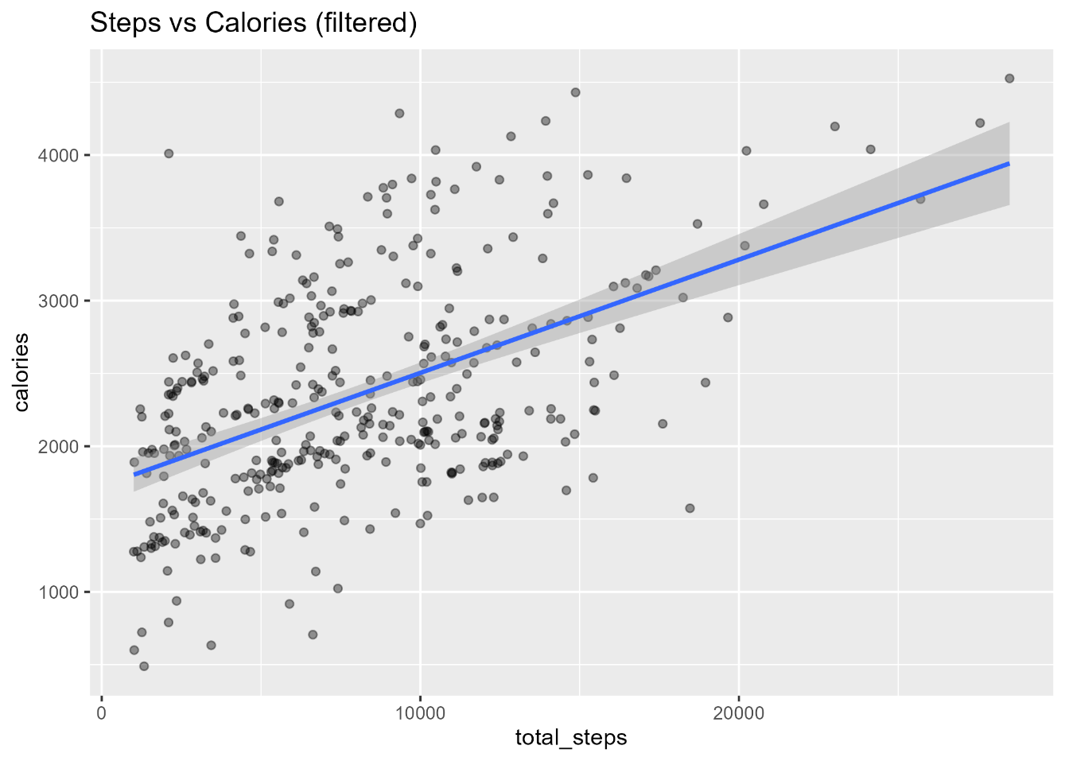
- (moderate positive relation, r ≈ 0.50).

- Per-user time series and distributions
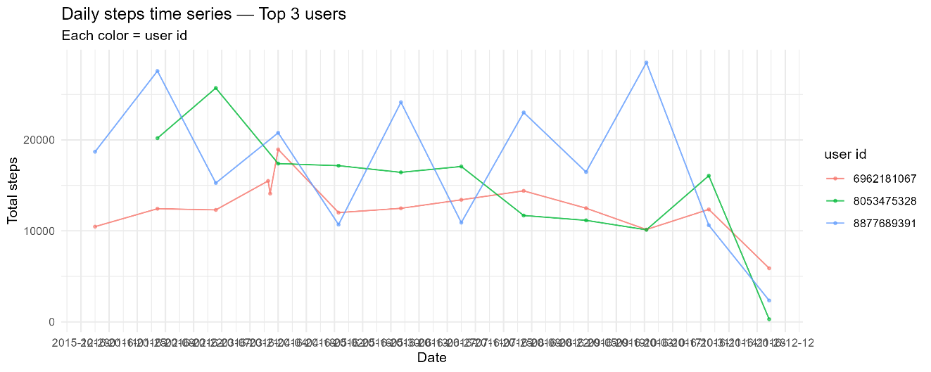
- for the most active users; show large day-to-day variance.

- Weekday vs weekend comparison
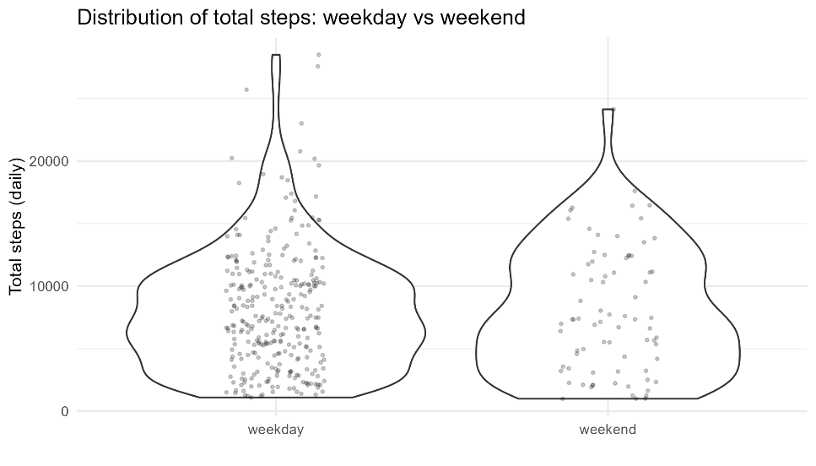
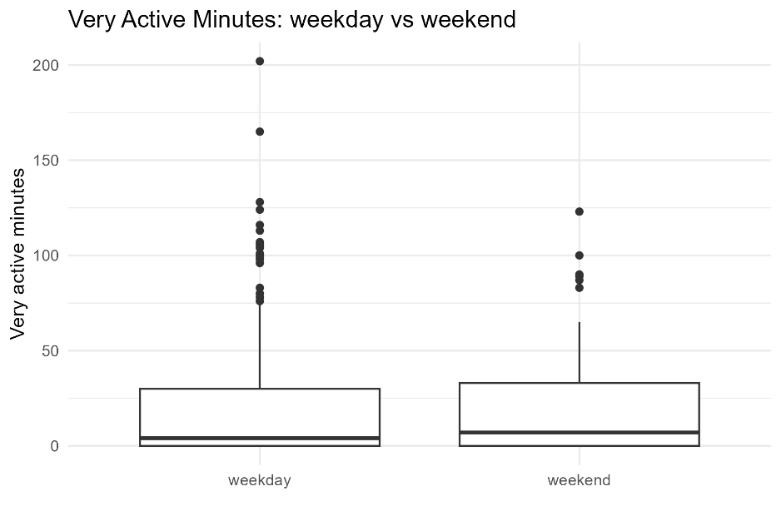

- no meaningful or consistent difference observed.

- Activity vs sleep

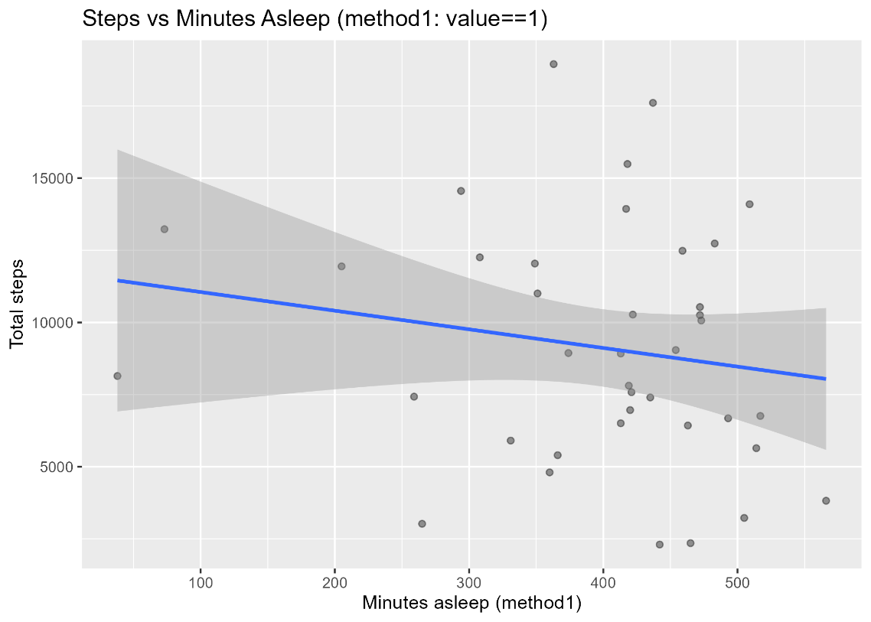

- (method1 = count minutes where value == 1): small matched sample (n = 39) and no significant linear relationship.

Concise key findings :
- VeryActiveMinutes is the most informative single activity metric — stronger predictor of exertion than step count alone.
- User behavior clusters cleanly into Low/Medium/High engagement segments (actionable for targeted messaging and monetization).
- No evidence that weekend days are systematically more (or less) active than weekdays in this sample — timing by hour-of-day is a more useful lever than day-of-week.
- Sleep and steps are not meaningfully correlated in our matched sample; do not claim sleep improvements from step-count-only interventions without further evidence.
- Heterogeneity matters: user-level variance is large (ICC ≈ 0.5 in activity models), so personalized or segment-based strategies will outperform one-size-fits-all campaigns.

Marketing recommendations (actionable & prioritized)
Priority 1 — Measurement & messaging (Immediate, high impact)
- Use very_active_minutes as the principal campaign metric. Phrase product messages around “minutes of activity” or “30 minutes active” rather than raw step counts — this aligns better with exertion and the strongest correlation found.
- Segment-based messaging: Use the three segments to tailor tone and offer:
  - Low: Micro-goals and simple nudges (7-day beginner challenges, 10-minute routines, daily reminders). Low friction, built-in rewards (badges) to drive initial activation.
  - Medium: Challenge-based campaigns and upsell pathways (30-minute challenges, weekly leaderboards, trial membership content).
  - High: Premium offers and insights (extended analytics, performance reports, early access features) to convert to subscription.
- Time-by-hour delivery: Schedule push notifications, content drops, and in-app prompts around late morning (11:30–12:30) and early evening (17:30–19:30) to match natural activity peaks.
Priority 2 — Product / monetization experiments (2–8 weeks)
- Test an A/B campaign promoting “30 minutes active” vs “10,000 steps” in similar user segments to measure which message lifts engagement and retention. Track activation, short-term activity increase, and conversion to trial membership.
- Small cohort RCT for sleep claims: If considering phrasing that “activity improves sleep,” run a controlled intervention with improved sleep measurement (e.g., require device wear overnight or integrate with validated sleep scoring) before public claims.
- Segment-specific onboarding flows: Build onboarding nudges and educational content that differ by segment (Low = onboarding + small wins; Medium = progressive goals; High = analytics + social features).
Priority 3 — Data & analytics investments (30–90 days)
- Increase matched day coverage for sleep analysis. Current matched sample (n=39) is underpowered. Options: extend data collection, request demographic fields, or combine with other datasets.
- Operationalize active-minute dashboards. Build a small marketing dashboard showing: segment counts, weekly retention by segment, active minutes trends, campaign lift (A/B), and hour-of-day engagement metrics.
- Adopt per-user modeling for notifications. Given high between-user variance (ICC ≈ 0.5), implement simple personalization rules (e.g., deliver push at user-specific peak hours observed historically).
KPIs to track
- Short term (campaign): uplift in very_active_minutes/day, activation rate (first 7 days), trial starts for membership offers.
- Medium term (behavior change): weekly retention (% returning weekly), conversion to paid membership, average active minutes per week.
- Long term (value): churn reduction, LTV uplift among converted users, and improvements in engagement rates for segmented campaigns.
Communication & compliance notes
- Avoid causal claims linking steps to improved sleep without validated sleep metrics and controlled testing. For all user-facing claims about health outcomes, maintain conservative, evidence-based language.

